**Installation and Deployment**

1. Go to Site content -> Site Assets where the app shall live
2. Create a new folder named "Event-Registration"
3. Click inside of the folder and upload the following:

* dist/event-registration.js
* dist/event-registration.min.js
* assets/eventreg-config.js
* assets/index.html

1. Navigate to Site Pages
2. Click New -> Web Part Page
3. Type the name of the page before ".aspx" (era is recommended) and select "Full Page, Vertical" for layout template.
4. Click "Add a Web Part" and set Categories to "Media and Content" and Parts to "Content Editor"
5. Click the dropdown arrow in the upper right corner and choose Edit Web Part
6. Under "Content Link" copy-paste link to index.html file and under "Appearance" set "Chrome Type" to None
7. Click Install on the Installation Required screen
8. Click Refresh after installation is loaded
9. Click Stop editing if present.
10. CONGRATULATIONS!!! ERA is now ready to go! It will appear similar to the screen below.
11. Installation

Prerequisites:

SharePoint set to Class Experience

1. Index.html
2. event-registration.js
3. event-registration.min.js
4. eventreg-config.json

Step 1)

Go to the SharePoint site where the app will be located and click Site contents -> Site Assets and create a new folder called “Event-Registration”

Step 2)

Upload all prerequisite files.

Step 3)

Click the Settings gear icon -> Site contents -> Site Pages -> New -> Web Part Page

Step 4)

Name the file. *It is recommended to use era.aspx and set the Layout Template to Full Page, Vertical

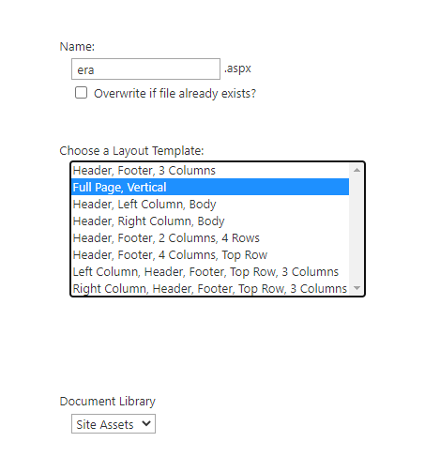

Step 5)

Click Add a Web Part. Under Categories choose Media and Content. Make sure Content Editor is chosen under Parts. And click add.

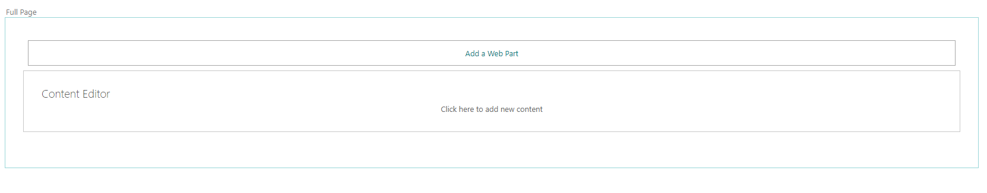

Step 6)

In the upper right hand corner of Content editor click the dropdown arrow -> Edit Web Part

Step 7)

Enter the URL from the top collection site to the index.html file in the Event-Registration folder.

Expand Layout and set Chrome Type to None.

Step 8)

Click Install on the appearing dialog.

Step 9)

Click Refresh when it appears on the dialog box

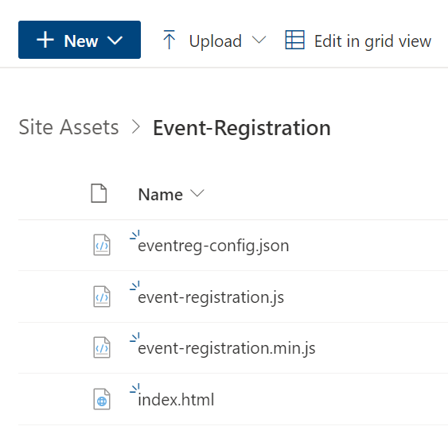

1. Create folder for project named Event-Registration on SP site
2. 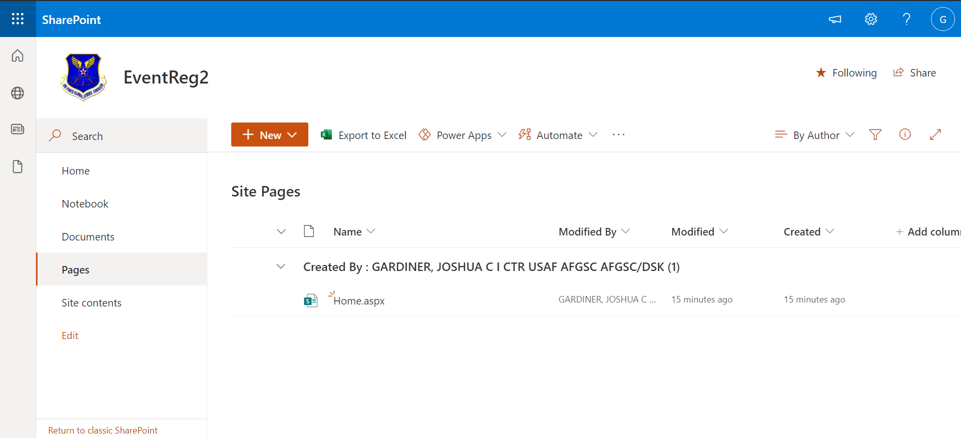

7) Upload event-registration.js and event-registration.min.js form dist directory

8) Upload index.html and event-config.json files from assets to directory

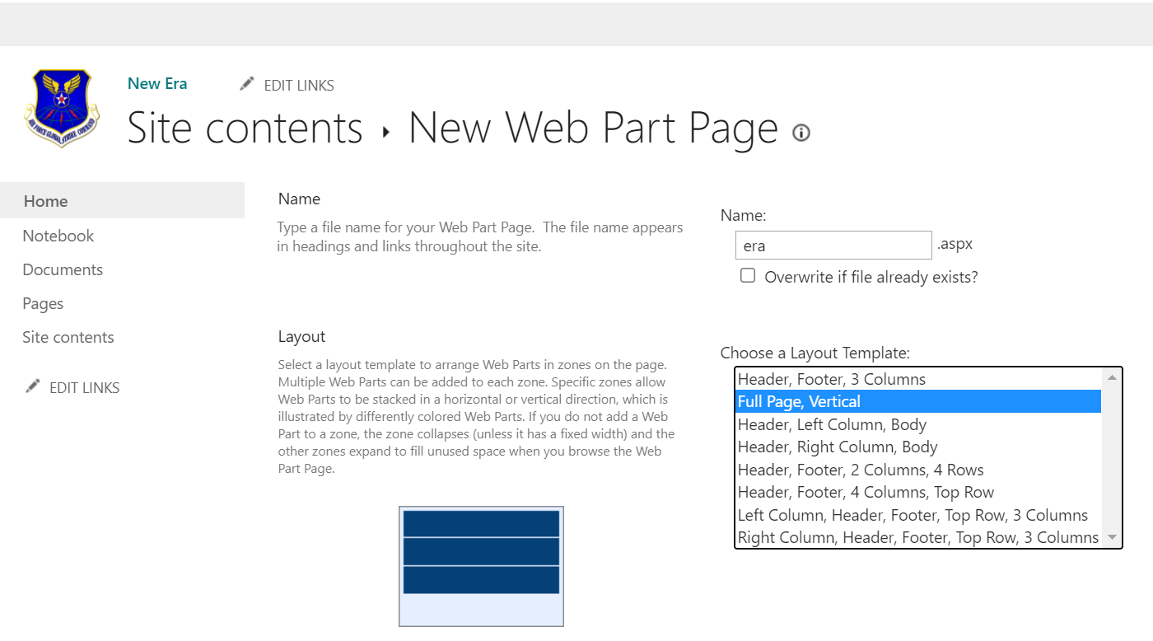

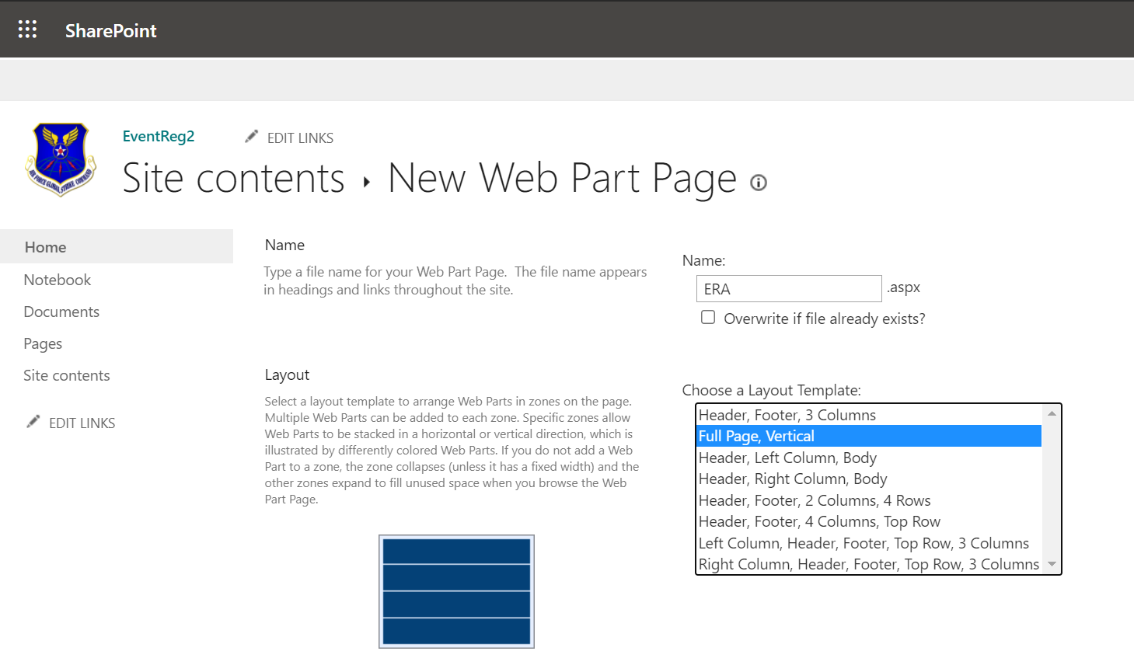

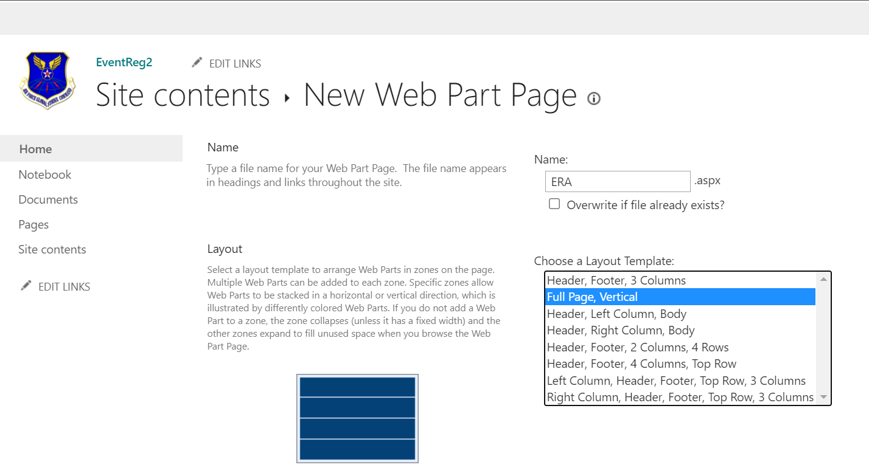

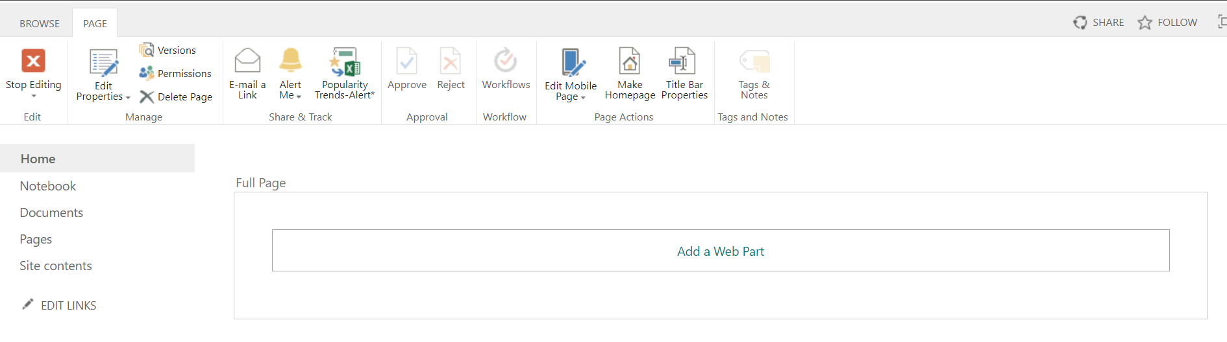

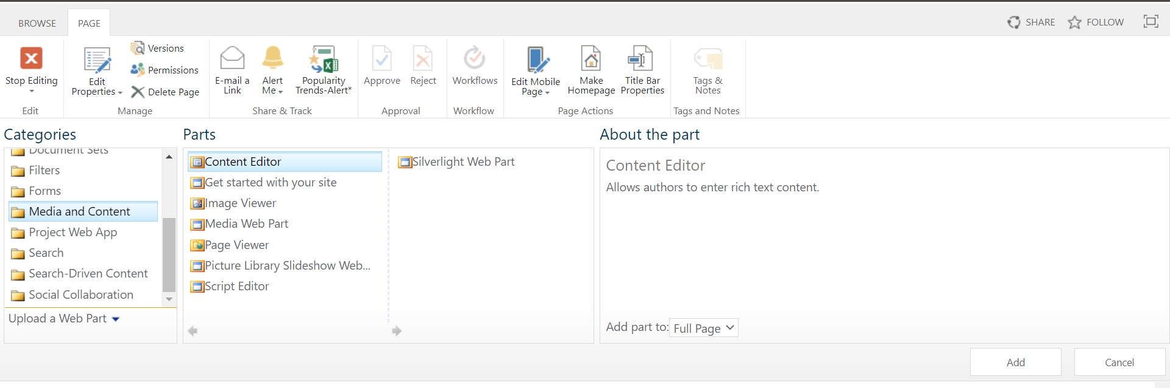

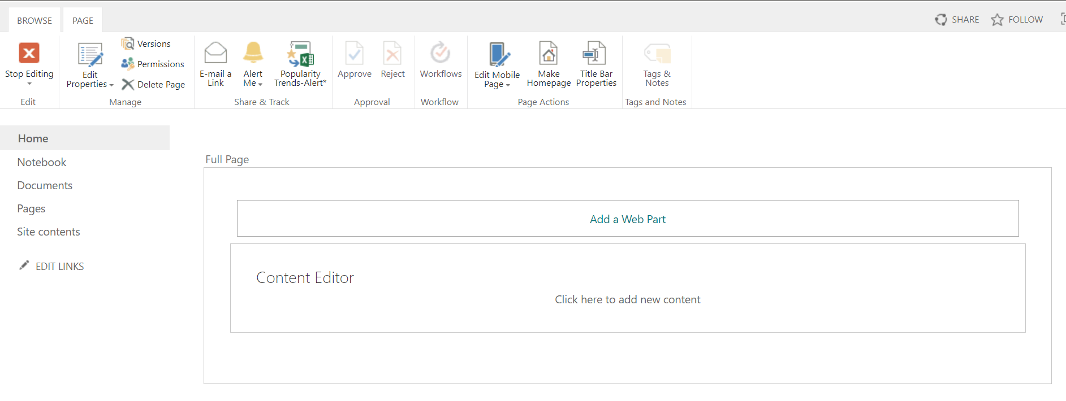

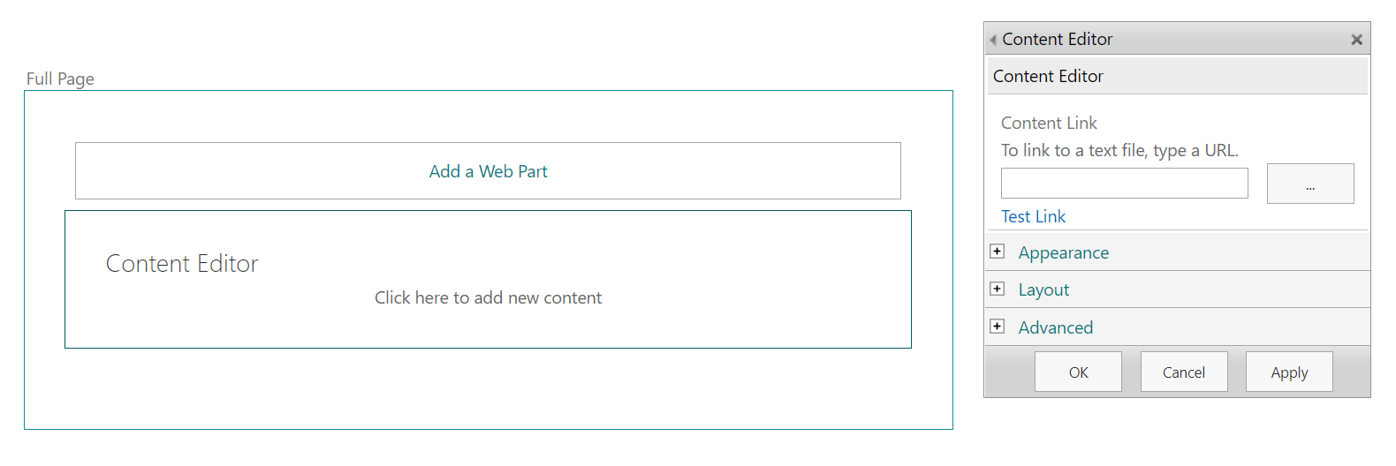

10) Click install and then refresh on appearing dialog

